Geometry of a Misperception: Distortions of the Apparent Midline in the Induced Roelofs Effect

Paul Dassonville, Emery Pinkert and Michael Kyweriga
Department of Psychology and Institute of Neuroscience, University of Oregon

Running head: Apparent Midline Distortion

Correspondence:
Paul Dassonville, Dept. of Psychology, 1227 University of Oregon, Eugene, OR 97403
(541) 346-4956, prd@uoregon.edu
Abstract
The apparent midline (or an observer's perception of straight ahead) plays a fundamental role in our ability to locate objects in space. Despite the apparent midline's potential fundamental importance in our ability to locate objects, our perception of straight ahead is vulnerable to distortion. In the present experiment, we examined the distortion of the apparent midline caused by the Roelofs effect, using stimuli presented in three-dimensional space to determine the geometry in which the apparent midline is distorted. Previous research using other paradigms has suggested that the distortion may be a rotation, translation, or warping, (Vallar, Guariglia, Nico, & Bisiach, 1995; Ferber & Karnath, 1999; Gogel & MacCracken, 1979). The perceptual errors for targets located at different depths from observers were compared to the errors predicted by the three potential types of distortion. Two experiments were run, the second of which addressed potential confounds in the initial design. The data from both experiments suggests that the geometry of the midline distortion is predominately a rotation. However, the axis of rotation indicated by the data is significantly behind the eyes (and head), suggesting that the distortion could include an additional translation component. The potential for a translational component may be supported by previous work indicating eye dominance switching based on stimulus characteristics and eye position in azimuth (Khan and Crawford, 2001; Banks, Ghose & Hillis, 2004).
One frame of reference that observers can theoretically use to encode the location of an object in space is the egocentric reference frame, which delineates space with respect to the self. Mergner, Nasios, Maurer & Becker (2001) have demonstrated that an important component of this reference frame is the observer’s subjective straight-ahead (SSA), which serves as the origin by which target locations are encoded. However, it has also been demonstrated that this origin is far from stable. For example, when an observer is shown a large illuminated rectangular in otherwise complete darkness, the SSA becomes biased in the direction of the rectangle’s center; that is, if the rectangle is presented in a location offset to the observer’s left, the SSA is pulled to the left, and vice-versa. This distortion of the egocentric reference frame causes a phenomenon known as the Roelofs effect, in which the illuminated rectangle is perceived to be less eccentric than its true position (Roelofs, 1935). Furthermore, the position of an object within the rectangle is usually reported to be shifted in the opposite direction (the induced Roelofs effect; Bridgeman, Peery & Anand, 1997), since, for example, the true position of an object presented within a left-shifted rectangle will appear to be shifted to the right with respect to the leftward-biased SSA (Dassonville & Bala, 2004; Dassonville, Bridgeman, Bala, Theim, & Sampanes, 2004).
Although the presence of a midline distortion is well-established as the cause of the original and induced Roelofs effects, the geometric nature of the distortion has yet to be characterized. When an observer makes a judgment about an object’s location in the azimuth, it is generally thought that the judgment is made with respect to an egocentric reference frame defined by an SSA that emanates from a point located somewhere between the two eyes (the visual egocenter, or cyclopean eye; Hering, 1868/1977). It follows, then, that the SSA can be thought of as a typically-parasaggital plane that passes through this point. Simplifying somewhat by considering only directions within the azimuth at eye level, the subjective midline can be thought of as a horizontal vector emanating directly from a cyclopean eye. Distortions of the subjective midline can thus be of three basic types. One possibility is that the subjective midline undergoes a rotation in the presence of a Roelofs-inducing frame, with the cyclopean eye serving as the point of rotation (Figure 1a). Alternatively, it may be that the subjective midline undergoes a translation, with a movement of the cyclopean eye toward the center of the offset frame (Figure 1b). Finally, the subjective midline could undergo a warping, causing it to be curved toward the center of the Roelofs-inducing frame before bending back to veridical beyond the frame (Figure 1c). Of course, it is also plausible that the true nature of the distortion is a combination of two, or all three, of these basic types.
In the present experiment, we used a variation of the induced Roelofs effect to determine the geometry of this midline distortion. Unlike previous studies, this experiment used target stimuli that were presented at different depths with respect to the Roelofs-inducing frame. Using this method of presentation, we were able to assess the magnitude and direction of the perceptual errors caused by the offset frame for targets at different distances with respect to the observer. Depending on the geometry of the apparent midline distortion, different patterns of perceptual errors were predicted. If the distortion of the apparent midline is a rotation, the magnitude of the error in target localization would linearly increase with the distance between the target and the observer (Figure 1a); a target to the left of straight-ahead would be correctly perceived as being to the left, but a more distant target with the same linear eccentricity would be perceived as being to the right of straight-ahead. On the other hand, if the distortion of the apparent midline is a translation, the magnitude of the observer’s perceptual error would remain constant at all target presentation depths (Figure 1b). Finally, a curvature of the subjective midline would cause a nonlinear relationship between distance and error magnitude, with, for example, the largest errors for targets at the same depth as the frame, but smaller errors for targets in front of and beyond the frame (Figure 1c).
The hypothesis that the apparent midline might undergo a translation in the direction of the offset frame is one that should be considered in more detail. In fact, the location of the cyclopean eye does not always lie at the geometric center between the eyes. Instead, its location can vary with the sighting eye (if only a single eye is used), or the dominant eye if both eyes are used (Francis & Harwood, 1951; Roelofs, 1959; Barbeito, 1980, 1981, Mansfield & Legge, 1996). This situation becomes even further complicated by the fact that the ‘dominant eye’ is not a static assignment as is typically thought, but can change depending on the pattern of visual stimulation. In particular, Khan and Crawford (2001, 2003) have shown that the dominant eye changes depending on the angle of gaze required to fixate a target, with targets on the observer’s left causing a left eye dominance, and targets on the right causing a right eye dominance. Banks, Ghose & Hillis (2004) subsequently demonstrated that this effect was not caused by gaze angle per se, but instead by the relative differences in image size in the left and right eyes caused by the different target locations (e.g., an object to the left will cast a larger image in the left eye than in the right).This latter finding suggests that the Roelofs effect, which is brought about by a large frame offset right or left of the observer’s midsaggital plane, may be caused by a tendency of the offset frame to cause the eye dominance to switch to the eye on the same side as the frame. For example, if a left-shifted frame causes the left eye to become dominant, then it might be expected that the cyclopean eye would be translated leftward. With respect to this leftward-shifted cyclopean eye, objects within the visual field would appear to be shifted in a rightward direction. Thus, a change in eye dominance would cause a translation of the subjective midline, providing a plausible mechanism for both the original and induced Roelofs effects.
In summary, the goals of this study were two-fold. First, we used virtual targets presented in three-dimensional space to quantify the geometry of the distortion of the subjective midline associated with the induced Roelofs effect. Second, we determined whether any translation component of this distortion could be explained by a change in eye dominance caused by the location of the offset Roelofs-inducing frame.

Experiment 1
Methods
Participants
Experimental procedures were approved by the Institutional Review Board at the University of Oregon, and all participants gave their informed, written consent to participate. Data were collected from 11 individuals (9 women), with two others excluded due to an inability to properly fuse the virtual 3-D images used in the experiment. Participants were University of Oregon undergraduate students that were compensated at a rate of $7.00/hr for participating, or with course credit to satisfy a requirement in an introductory psychology course. All participants had normal or corrected-to-normal visual acuity, with stereoscopic acuities no worse than 60 arc seconds (Stereotest-Circles, Stereo Optical Co., Inc.). Eye dominance was tested by having each participant look through a plastic funnel (with the large opening positioned just in front of his or her face and eyes) at the researcher’s nose, which allowed the researcher a view of the dominant eye (Miles, 1929, 1930). Eight participants were right eye dominant, three were left eye dominant.

Apparatus
Participants were placed in a darkened room, and viewed stimuli which were back projected by a Barco Cine7 projector onto a screen (128 x 96 cm) positioned 122 cm from the participant’s eyes. To reduce light scatter, the blue and green CRTs of the projector were covered, and stimuli were drawn exclusively in red. A chinrest was used to ensure consistent viewing distance and height (130 cm), and an adjustable chair was provided to the participant so that a comfortable seating position could be attained with the head in the required position. In conjunction with the back projected image, an LCD goggle system (StereoGraphics CrystalEYES CE-3 goggles and EPC-2 synchronization unit) were used to create virtual images in 3-D space. Participants responded to computer-generated verbal prompts by pressing one of two keys on a computer keyboard; which were marked with putty to facilitate their localization in the darkened viewing conditions. The keyboard was placed directly in front of the participant during the course of the experiment.

Stimuli
Through the use of the StereoGraphics system and custom software (written in the lab using C and the VideoToolbox; Pelli, 1997), a convincing perception of depth was created using the depth cues of stereopsis, apparent height, relative size, linear perspective and convergence (the stimuli descriptions that follow are reported as they appeared from the perspective of the participant; the size and locations of the stereoscopic images were adjusted to yield the desired perception). During each trial, the participants made two perceptual judgments, with the first used to assess the magnitude of the induced Roelofs effect and the second used to assess eye dominance. The visual targets presented to the participant were red filled circles 0.5 cm in diameter, positioned either ##, ##, ##, ## or ## cm from the observer’s midsagittal plane, 4 cm above eye level, with a virtual depth of ## or ## cm from the participant’s eyes. In a given trial, a single target was initially presented in the context of a large horizontal rectangular frame (60 x 20 cm, with edges 2 cm wide) located at a depth of 97 cm. After the participant responded to the target’s location, an additional small square (4 x 4 cm, with edges 0.2 cm wide) was added to the display, located either ## cm directly in front of or ## cm directly behind the target.

Procedure
After receiving informed consent, and answering a set of demographic questions, participants were tested for appropriate stereoscopic depth perception. After fulfilling this requirement, participants were led into the darkened run room and were allowed to position themselves comfortably in the chinrest. The participant first completed a practice session to allow them to learn the possible target locations. Participants were first presented with all 25 target dots with the azimuth and depth positions labeled with red numbers presented next to the corresponding rows and columns of the grid. In this way, each target dot could be localized by a set of two numbers, the first representing the depth location and the second the azimuth location. This reference grid served as a learning aid and was presented between the practice session trials to help participants learn the spatial locations of targets in the grid. After viewing the reference grid briefly, the participants were presented with a single target dot and prompted by the computer-generated phrase “Near-far.” After hearing the prompt, the participant would respond by pressing the number key associated with the depth location of the target dot. Immediately after the response, the computer generated voice would indicate if the participant was correct or incorrect, and if incorrect, what the actual position number was. The participant would then be prompted with the phrase “Left-right,” at which point the participant would press the number key associated with the azimuth position of the target dot. The computer would again provide immediate feedback on the participant response. Before beginning the next practice trial the reference grid was presented to the participant with the target dot from the last practice trial highlighted. The participant was allowed to view the reference grid until they pressed the spacebar to begin the next practice trial. Participants continued with practice trials until they had correctly localized 20 target dots. Once the practice trials were complete, the participant was informed that they would begin the experimental portion of the experiment.
Test trials were similar to the practice trials, with the following differences. During the test session participants did not receive any feedback, the computer no longer indicated the accuracy of the response and the reference grid was not presented between trials. In addition, during two-thirds of the test trials, the Roelofs-inducing frame was presented while the participant localized the target dot. All possible target depth locations were presented during the test trials, but only the -4 cm, 0 cm and 4 cm azimuth positions were tested (Fig. 3). All combinations of these positions were presented with no frame, a left-shifted frame and a right-shifted frame. Each combination of these conditions was presented 6 times for a total of 270 test trials. These trials were presented in a semi-random order with each of 6 blocks being individually randomized for each participant. After completing the experiment, the participants were debriefed and any questions they had were answered as is required by the Human Subjects Pool at the University of Oregon.

Results
The average perceptual errors of the azimuth position of target dots for the 18 subjects are plotted in Figures 4a and 4b. In Figure 4a, the actual depth location of the target dots are plotted against the average perceptual error in the azimuth location of the targets. The data is sorted by frame location with a linear regression performed for each frame condition. Each data point indicates the average amount of error in the reported azimuth position of the targets presented at each depth location when presented with no frame, a left shifted frame, or right shifted frame. A positive value on the y axis indicates an error to the right in the reported target azimuth position, with a negative value indicating an error to the left. Figure 4b is a plot identical to the first except that the perceptual errors are plotted with respect to the perceived depth locations of the targets. All statistical analyses were conducted with the perceived depth location data rather than the actual depth. Linear regressions of the average data indicate that, in the left frame condition, as the perceived depth location of the target increased the amount of error to the right in the reported azimuth increased, β=.024, t(3)= 13.304, p=.001. Similarly, in the right frame condition as the target depth increased the amount of error to the left in the reported azimuth increased, β= -.015, t(3)= -6.827, p=.006. To distinguish between a rotation and a translation of the apparent midline, the slopes of the regression lines in the left and right frame conditions were statistically compared. If the distortion was a translation of the apparent midline, the slopes of the regression lines for the left and right frame conditions would not be expected to be significantly different from each other. However, this comparison revealed that the two regression lines had significantly different slopes, t(6)= -13.794, p<.001, suggesting that the distortion of the apparent midline is a rotation. An identical analysis of the data from each individual revealed that, of the 18 participants, the data of 9 individuals showed a significant difference in the regression slopes, p≤.05, with two additional participants approaching significance. All of these individual data sets indicated a divergent pattern of errors further supporting the rotational distortion hypothesis.
The analysis of the average data set revealed that, in addition to the slopes of the regression lines, the intercept locations of the two regression lines were significantly different, t(6)= -4.098, p=.006. This trend was also found in some of the individual participant’s data sets with 3 of the 18 individuals demonstrating a significant difference in the intercept points, p≤ .05. An additional 3 individuals demonstrated a difference in the intercept points that was approaching significance. All but one of these individuals demonstrated a difference in the intercept points causing the regression lines to intersect behind the depth plane of the eyes. The participant whose data suggested an intercept difference in the opposite direction, causing the regression lines to intersect in front of the depth plane of the eyes, was one of the individuals whose intercept difference was approaching significance.

Discussion
The data clearly suggest a rotation as the geometry of the midline distortion. The data do not indicate a warping of the apparent midline, since there is no evidence of a decrease in the illusion effect as target distance beyond the depth of the frame was increased. The significant linear relationships and the significant difference in the slopes of the left and right frame conditions are indicative of a rotation. However, the location of the axis of this rotation is unexpected. The widely accepted hypothesis of Hering (1977) suggests that the origin of visual references to locations in space is a central cyclopean eye located midway between the eyes. While a rotation of the apparent midline would fit nicely with this theory, it does so only if the axis of rotation lies approximately midway between the eyes. In our first experiment this is not the case. A linear regression of the frame conditions in the average dataset revealed a statistically significant difference in the intercepts for the left frame and right frame conditions at the depth of the eyes, with the regression lines not actually intersecting until approximately 40 cm behind the depth plane of the eyes.
Further examination of the data revealed a source of concern for the validity of the significant intercepts. On average, participants appeared to be unable to discriminate between the targets located 147 cm and 172 cm from the participant (i.e., the two farthest target locations). In addition, a possible edge effect was created by testing participants on the closest and farthest depth positions (Fig. 3), allowing variance in participants’ location reports to occur in only one direction for targets located at these depths. It was hypothesized that these artifacts may have led to the unexpected location of the rotation point by artificially compressing the tested depth range. To correct for these potential problems a second experiment was designed.

Experiment 2
To correct for the potential confounds created by the initial experimental design, a second stimulus set was created to address the potential issues and determine the validity of the significantly non-zero intercept location of the regression lines. To correct for the potential edge effects created by testing all of the possible depth locations in the first experiment, a larger grid was created so that only a subset of the learned depth locations could be tested during the data collection (Fig. 5). A larger grid was also used so that a greater number of target depth locations could be tested. Because of the unexpected location of the rotation point suggested by the initial data, the new target grid included targets at depth locations closer to the observer in an attempt to gather data that would better estimate the midline distortion at the depth of the eyes. In addition to the desire to collect data from locations closer to the participant, the targets were presented closer to the observer to avoid presenting targets beyond 147 cm as pixilation of the display image was hypothesized to have contributed to the lack of discrimination of the two farthest target depths in Experiment 1. In another attempt to compensate for the pixilation of the far target locations, the targets dots were also increased in size to 0.5 cm in diameter.

Methods
Participants
In Experiment 2, data was collected from 20 individuals, 15 women and 5 men. The majority of the participants were students enrolled in introductory psychology classes at the University of Oregon and were recruited though the University’s Human Subjects Pool; however, two participants were recruited through sign up sheets that had been posted at the University and received pay for their participation. All participants had normal, or corrected to normal visual acuity. Participants’ stereoscopic acuity ranged from 140 to 40 arc seconds with a mean of 51.5 arc seconds. Most participants (18) received credit to satisfy the requirements of their undergraduate classes as compensation for participating in this experiment. The data of one individual was not included in the analysis since that individual’s data did not demonstrate a significant susceptibility to the induced Roelofs effect.

Apparatus
An apparatus identical to that of Experiment 1 was used in Experiment 2, with the following exception. In place of the keyboard, the participants responded to the computer-generated prompts using a ten button interface split between two button boxes. Each button box had five buttons arranged in an ergonomic fashion to be used by the left or right hand. These buttons were labeled sequentially with the numbers 1-10, with the button to be pressed by the little finger of the left hand representing 1 and the button to be pressed by the little finger of the right hand representing 10.

Stimuli
For Experiment 2, the visual targets presented to the participant where 50 red spots, 0.5 cm in diameter, positioned in a 5 x 10 grid. This grid was arranged in a horizontal plane extending away from the participant 4 cm above eye level, with the closest row of targets located 37 cm from the participant with each successive row located 15 cm further from the observer in depth. The azimuth positions of the targets in each row were -8 cm, -4 cm, 0 cm, 4 cm, and 8 cm relative to straight ahead. Participants were also presented with a large red frame (width = 60 cm, height = 20, thickness = 2 cm) which was presented 97 cm from the participant, 12 cm to the left or right of straight ahead.

Procedure
A procedure similar to that used in Experiment 1 was used in Experiment 2. Practice trials were first administered to allow the participant to learn the possible locations of the target dots. The participants received feedback in an identical manner to the participants in Experiment 1. Participants completed the practice session when they had correctly located the depth location of 20 target dots in addition to correctly identifying the azimuth position of 20 target dots. This was a slight variation from the method used in Experiment 1, but was done because of the increased difficulty of the new task with twice the number of possible target locations. In addition to this difference the validity of the participants’ depth reports were determined in a slightly different manner. When prompted “near-far,” a participant’s report for the depth of the target was considered correct if the response was equal to the actual value, or greater or less than the correct answer by one unit. In this latter case, the participant would still be informed by the computer that the answer was incorrect, but the trial would count towards fulfilling the requirements to finish the practice session.
During the test session the participants were tested on only a subset of the possible target locations. These included azimuth positions at -4 cm, 0 cm and 4 cm, as in Experiment 1, but only a subset of depth positions, (52 cm – 142 cm), were tested as well. Each possible location was tested with no frame, a left shifted frame, or a right shifted frame 4 times for a total of 252 trials. These trials were presented in a semi-random order as in Experiment 1, and, once completed, the participant was debriefed.

Results
The averaged data from the second experiment is plotted in Figure 6. These plots where constructed in an identical fashion to those in Experiment 1. Analysis was again conducted using the perceived depth location (Fig. 6b) as opposed to the actual depth location of target dots (Fig. 6a). The data contributed by one participant was not included in the analysis because an ANOVA revealed no significant induced Roelofs effect, F(2,6) = .663, p = .549. (Because the goal of the present experiment was to determine the geometry of the midline distortion caused by the induced Roelofs effect, it was considered inappropriate to include the data of an individual who did not demonstrate susceptibility to the illusion.) In a similar fashion to Experiment 1, linear regressions were performed on the averaged data. In the left frame condition, a linear trend between depth location and azimuth error approached significance β= 0.006, t(6)= 2.35, p=.066. In the right frame condition, as the target depth increased, the amount of error to the left in the reported azimuth increased in a linear fashion, β= -0.014, t(6)= -5.323, p = .003. As in Experiment 1, a significant difference between the slopes of the regression lines of the left and right shifted frame conditions was found, t(10)= -8.579, p < .001. An examination of the individual data sets supported this finding, with 9 of the 19 participants showing a significant (p < .05) difference in the slopes, all of these suggesting a diverging pattern of errors, supporting the rotational distortion.
The analysis of the averaged data set also revealed a significant difference in the intercept points for the regressions of the right and left frame conditions, t(10)= -5.351, p < .001. This result was substantiated by the individual data sets in which 11 of the 19 participants demonstrated a significant (p < .05) difference in the intercept points and an additional 3 individuals demonstrated a difference that was approaching significance. All 14 of these individual data sets suggested a rotation point located behind the depth plane of the eyes.

Discussion
The data from both experiments suggest that the distortion of the apparent midline under the conditions that cause the induced Roelofs effect is a rotation. However, the data from both experiments also indicate that the position of the rotational axis of this apparent midline distortion is located significantly behind the depth plane of the eyes and even behind the head in its entirety. These data are inconsistent with the widely accepted hypothesis that the origin of the egocentric reference frame is located at an egocenter positioned midway between the eyes (Dengis et al., 1998). If the results of these experiments were to be congruent with the cyclopean eye theory, the regression lines of each of the frame conditions in both experiments would be expected to intersect at the origin, the approximate location that the suggested egocenter would have been. A visual inspection of the data clearly suggests that the results obtained are quite different from this hypothesized situation, and the statistical analyses supported these observations.
However, a rotation point located 40 to 150 cm behind the depth plane of the eyes is not easily explainable with a logical biopsychological argument. An alternative interpretation of the data is that it may be considered to indicate a distortional geometry with both rotational and translational components. While it is mathematically impossible to differentiate between a distortion that is a pure rotation and one that has both rotational and translational components, a growing body of research indicates that a translational component may in fact be expected. The work of Kahn & Crawford (2001) suggests that individuals demonstrate a switch in eye dominance depending on the azimuth position of the visual stimulus being fixated. Their research suggests that for targets to the left of the observer, the left eye is more dominant, with the reverse being true for targets to the right. The work of Banks, Ghose & Hillis (2004) suggests evidence of eye dominance switching in a similar vain. However, Banks et al. suggest that fixation location merely serves to modulate the relative retinal image size of the stimuli seen by each eye and that it is this difference in image size (rather than the fixation location per se) that causes the eye dominance to switch.
The work of Banks et al. (2004) and Kahn & Crawford (2001) suggests that a similar eye dominance switching phenomena would occur in the conditions present in the induced Roelofs effect illusion. A systematic switch in eye dominance based on target and frame location during experimental trials could provide a reasonable explanation for the unexpected location of the rotation point suggested by the data from these experiments. If eye dominance switching similar to that found in this previous work occurred during our experiments, a translational component in the distortion geometry would be expected, in addition to the rotation suggested by the present results.

Neglect is a neurological disorder that inhibits an individual’s ability to detect or respond to stimuli in one hemispace, most commonly caused by right temporo-parietal lesions. Individuals with visual-spatial or auditory neglect show profound errors in their perceived midsagital plane (Vallar, Guariglia, Nico & Bisiach, 1995; Kerkhoff, et al., 2006; Ferber & Karnath, 1999). In subjective straight-ahead localization tasks, individuals with neglect consistently show a bias toward their ipselesional side. Though the error in the perception of straight ahead can be very dramatic in individuals with neglect, the shape of the distortion of the egocentric reference frame has not been clearly determined. While some data seem to suggest a translation of the egocentric reference frame (Vallar et al., 1995), other studies (Ferber & Karnath, 1999; Kerkhoff et al., 2006) have suggested that the reference frame is distorted in a rotational manner.

A third potential geometry could be a warping of the apparent midline, with the apparent midline shifted in the direction of the frame the greatest amount at the depth of the frame, with less distortion of the midline at other depth locations (Fig 1c). This potential geometry is suggested by the work of Gogel & Mac Craken (1979) with induced motion experiments, and by Gogel & Newton (1975) with experiments illustrating the depth adjacenty effect in the rod and frame illusion. In these experiments, targets were presented at different depths with respect to the illusion-inducing stimuli. Gogel & Mac Cracken found that the inducing stimulus caused the greatest perception of induced motion of the target stimulus when the target and inducing stimuli were presented at the same depth location. The magnitude of the induced motion decreased as the distance between the target stimulus and inducing stimulus was increased, for conditions in which the target stimulus was both closer and farther than the inducing stimulus. Similarly, Gogel & Newton found that the induced rotation of a rod caused by a rotated frame was greatest when the two stimuli were at the same depth location, and the effect decreased in magnitude as the depth difference of the two stimuli were increased. If the apparent midline is distorted with a similar warped geometry in the induced Roelofs effect, it would be expected that the error of perceived azimuth would be greatest for targets presented at the same depth as the frame, with decreasing effects as the distance between the target and the frame was increased.
References
Banks, M.S, Ghose, T., & Hillis, J. M. (2004). Relative image size, not eye position, determines eye dominance switches. Vision Research, 44, 229-234.
Bridgeman, B., Peery, S., & Anand, S. (1997). Interaction of cognitive and sensorimotor maps of visual space. Perception & Psychophysics, 59, 456-469.
Brosgole, L., (1968). An analysis of induced motion. Acta Psychol (Amst), 28, 1–44.
Dassonville, P., Bridgeman, B., Bala, J. K., Theim, P., & Sampanes, A. (2004). The induced Roelofs effect: Two visual systems or the shift in a single reference frame? Vision Research, 44, 603-611.
Dassonville, P. & Bala, J. K. (2004) Action, perception and Roelofs effect: A mere illusion of dissociation. PLoS Biology, 2, 1936-1945.
Dengis, C. A., Simpson, T.L., Steinbach, M. J., Ono, H. (1998). The cyclops effect in adults: sighting without visual feedback. Vision Res., 38, 327-33
Ferber, S. & Karnath, H. -O. (1999). Parietal and occipital lobe contributions to perception of straight ahead orientation. Journal of Neurology, Neurosurgery & Psychiatry, 67, 572-578
Gogel, W. C. & MacCracken, P. J. (1979). Depth adjacency and induced motion. Perceptual and Motor Skills, 48, 343-350
Gogel, W.C. & Newton, R.E., (1975). Depth adjacency and the rod-and-frame illusion. Perception and Psychophysics, 18, 163-171.
Hering, E. (1977). In Bridgeman, B. & Stark, L., (Eds.), The theory of binocular vision (B. Bridgeman, Trans.). New York: Plenum Press (original work published 1868).
Karnath, H. -O. (1997). Spatial orientation and the representation of space with parietal lobe lesions. Philosophical Transactions of the Royal Society, London B, B352, 1411–1419.
Kerkhoff, G., Schindler, I., Artinger, F., Zoelch, C., Bublak, P. & Finke, K. (2006). Rotation or translation of auditory space in neglect? A case study of chronic right-sided neglect. Neuropsychologia, 44, 923-930.
Khan, A. Z. & Crawford D., (2001). Ocular dominance reverses as a function of horizontal gaze angle. Vision Research, 41, 1743–1748.
Mergner, T., Nasios, G., Maurer, C., & Becker, W. (2001). Visual object localisation in space: Interaction of retinal, eye position, vestibular and neck proprioceptive information. Experimental Brain Research, 141, 33-51.
Miles, W.R. (1929). Ocular dominance demonstrated by unconscious sighting. Journal of Experimental Psychology, 12, 113-126.
Miles, W.R. (1930). Ocular dominance in human adults. Journal of General Psychology, 3, 412-420.
Moidel, B., Steinbach, M. J. & Ono, H. (1987). Egocenter location in children enucleated at an early age. Investigative Ophthalmology & Visual Science, 29, 1348-1351.
Pelli, D.G. (1997) The VideoToolbox software for visual psychophysics: Transforming numbers into movies. Spatial Vision 10:437-442
Vallar G., Guariglia C., Nico D. & Bisiach E. (1995). Spatial hemineglect in back space. Brain, 118, 467-472
Vallar, G. (1997). Spatial frames of reference and somatosensory processing: a neuropsychological perspective. Philosophical Transactions of the Royal Society, London B, B352, 1401–1409.
Werner, H., Wapner, S., & Bruell, J. (1953). Experiments on sensory-tonic field theory of perception: VI. The effect of position of head, eyes and of objects on the position of the apparent median plane. Journal of Experimental Psychology, 46, 293-299

Figures

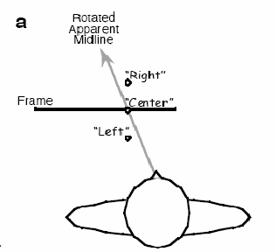
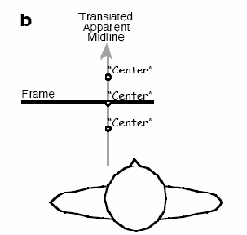
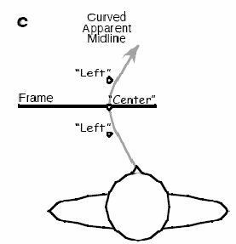

Figure 1. Differential Patterns of Perceptual Errors: a, b and c illustrate the differential patterns of perceptual errors for targets at different depth locations that could be created in the induced Roelofs effect depending on the geometry of apparent midline distortion. “Right”, Left” and “Center” depict the hypothetical responses that would be provided for each target location in a task in which the participant was required to report the target location with respect to the apparent midline.

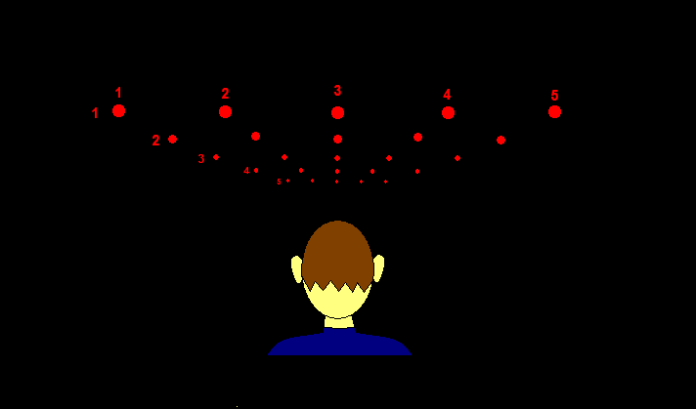

Figure 2. Target Stimuli Grid: This figure illustrates, in 2 dimensions, the 3 dimensional stimuli set that was used in Experiment 1. Targets (25 red dots) were arranged in a 5X5 grid that extended in a horizontal plane away from the participant.

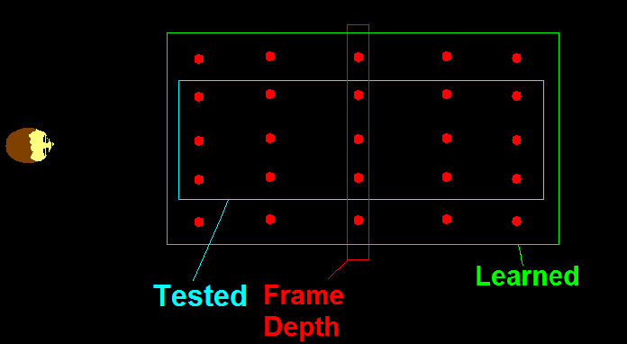
Figure 3. Experiment 1 Schematic: During practice trials the participants learned all target locations. During the testing phase participants were presented with targets at only the -4 cm, 0 cm and 4 cm azimuth positions, but all depth locations were tested.

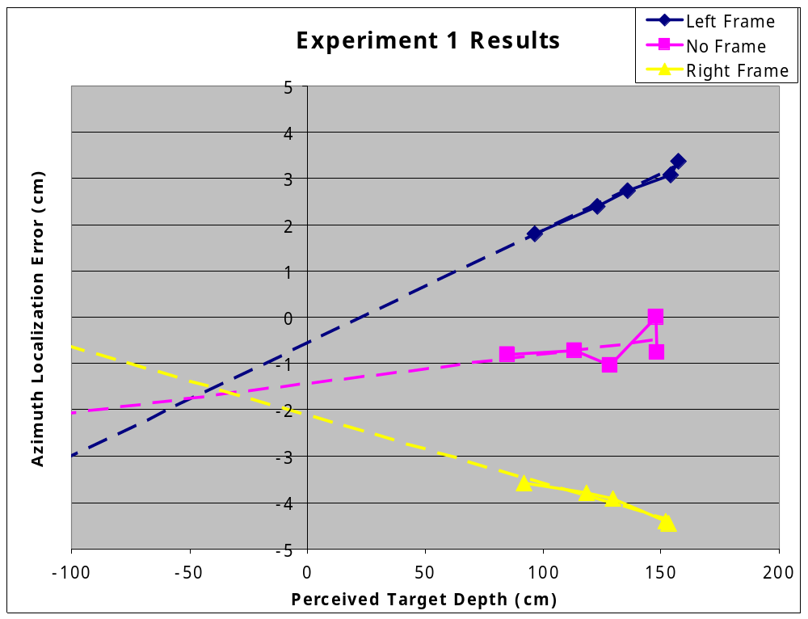
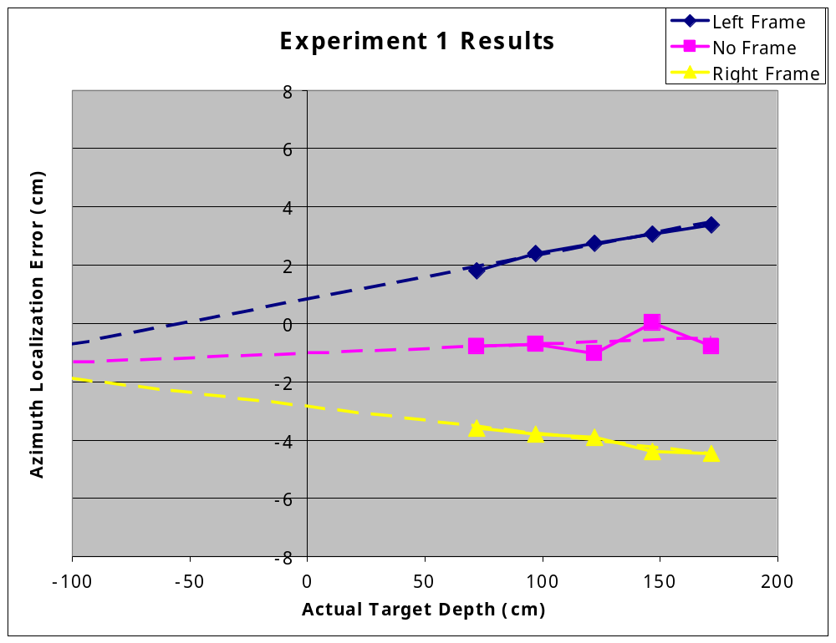
a.

b.

Figure 4. Experiment 1 Results: Plots of the average error in the participant reports for target azimuth at each depth in the no frame condition, the right and left shifted frame conditions, plotted with respect to the actual target depth (a) and the perceived target depth (b).

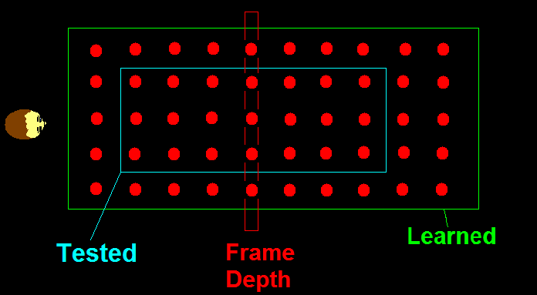
Figure 5. Experiment 2 Schematic: During practice trials participants learned all target locations. During the testing phase participants were presented with targets at only the -4 cm, 0 cm and 4 cm azimuth positions. The depth locations of 37 cm, 157 cm and 172 cm were not presented during experimental trials.

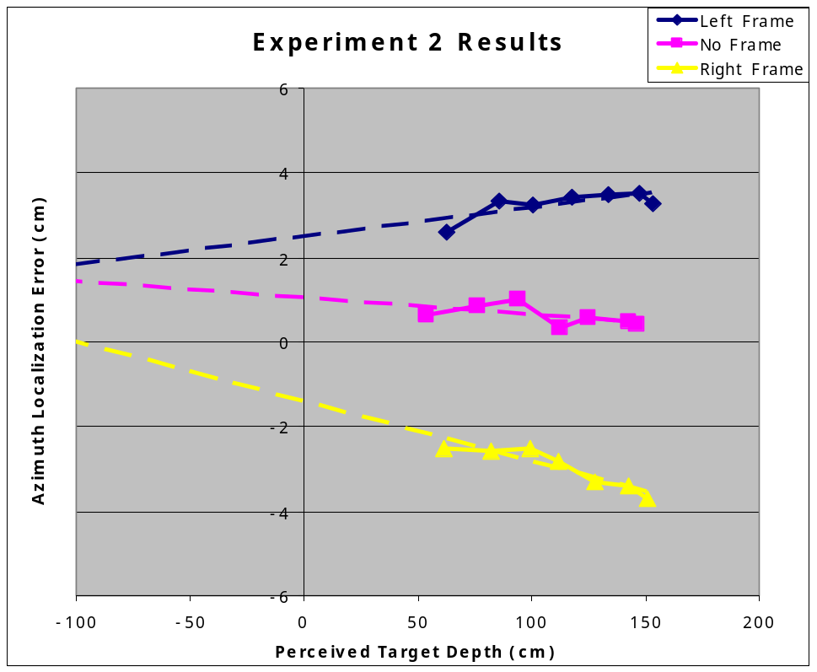
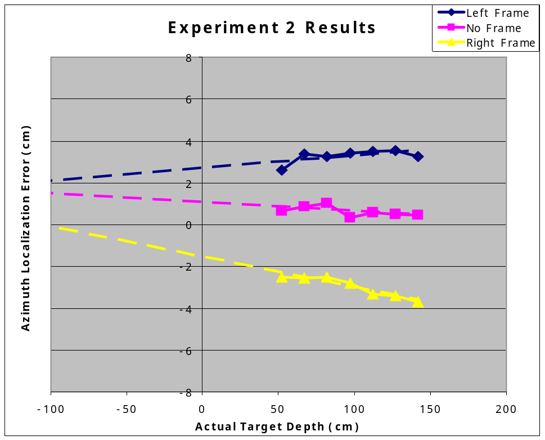
a.

b.

Figure 6. Experiment 2 Results: Plots of the average error in the participant reports for target azimuth at each depth in the no frame condition, the right and left shifted frame conditions, plotted with respect to the actual target depth (a) and the perceived target depth (b).

